Lab 4

1.

1. <https://developer.chrome.com/docs/devtools/> (pentru mai tarziu)
2. Am ales: <https://www.airbnb.com.ro/?_set_bev_on_new_domain=1634815163_ZTc0NThkN2IyZWFl> , <https://www.shopify.com/> si <https://wistia.com/>

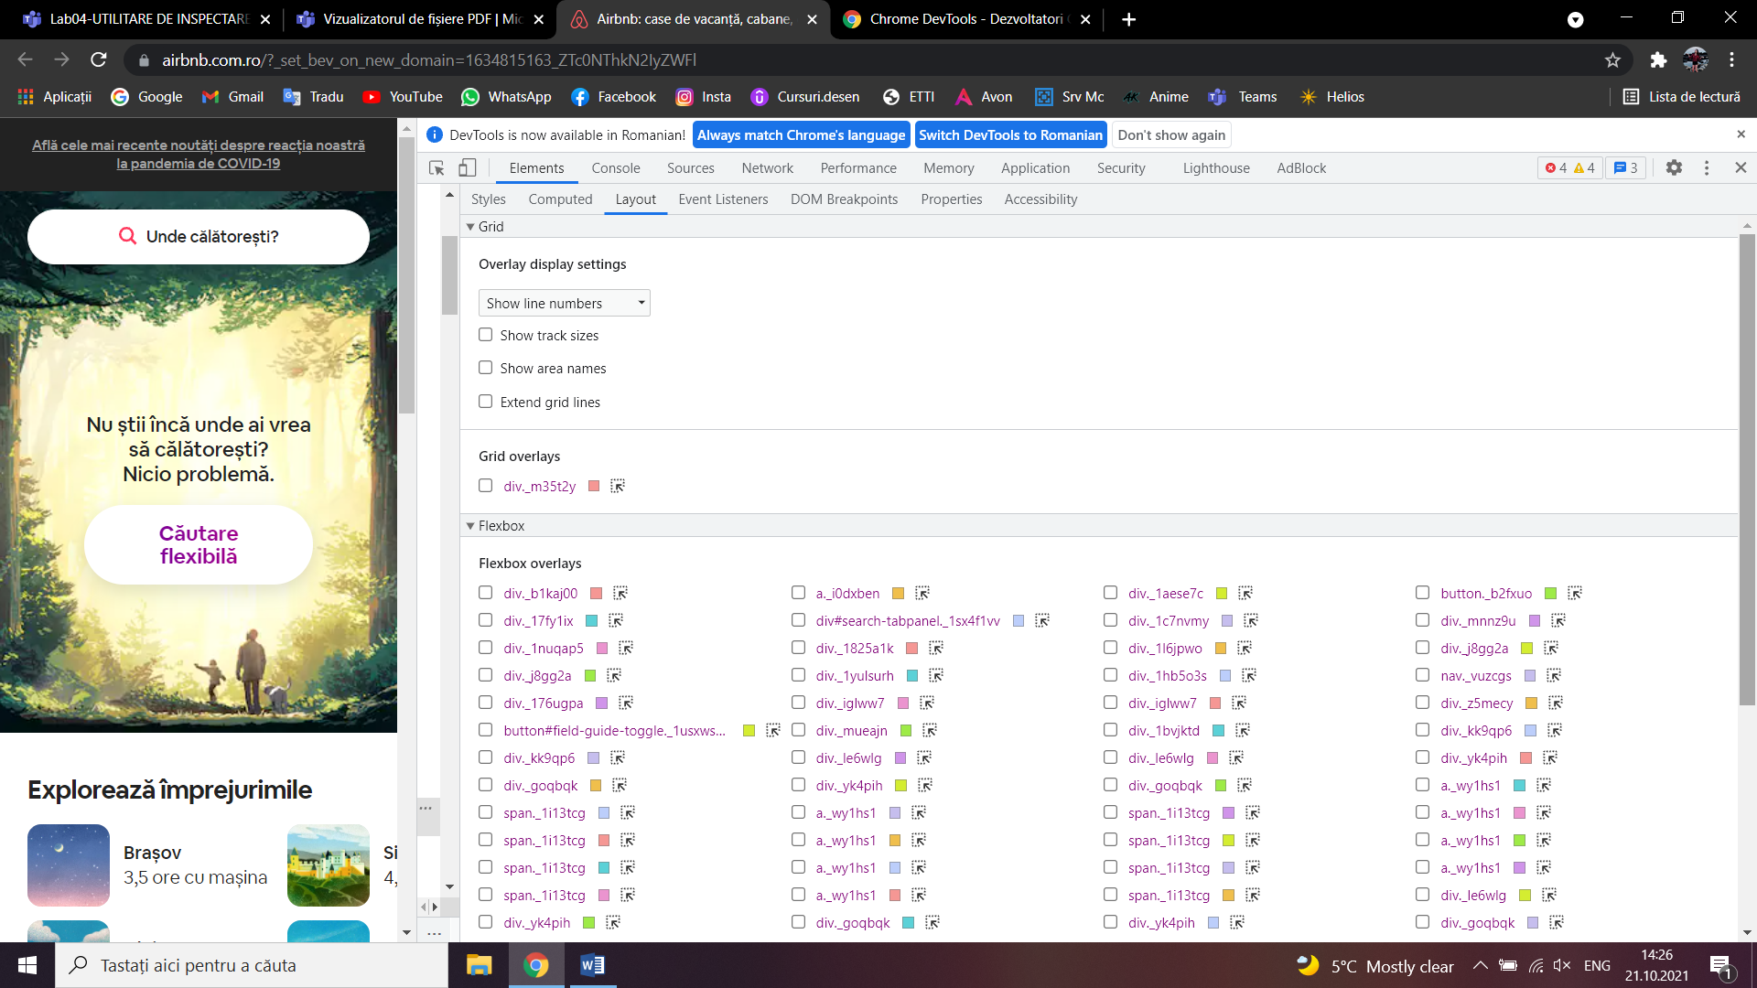

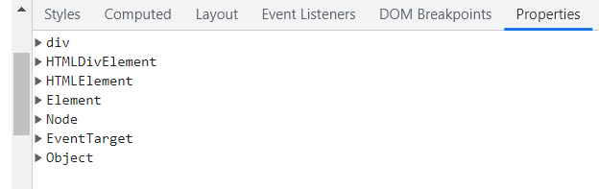

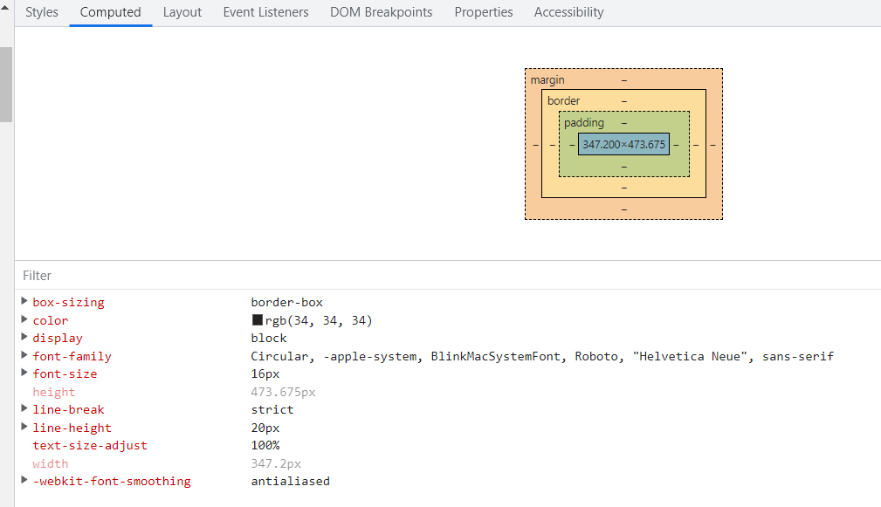

<https://www.shopify.com/>

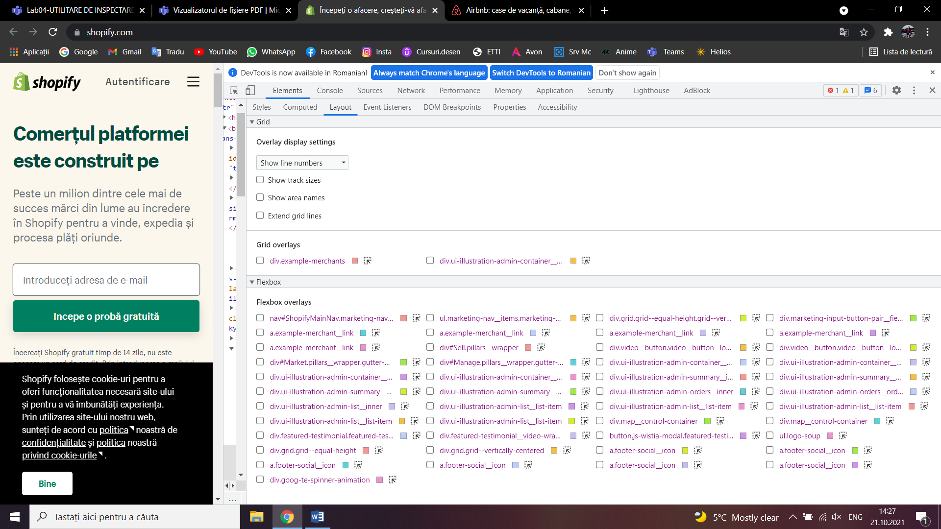

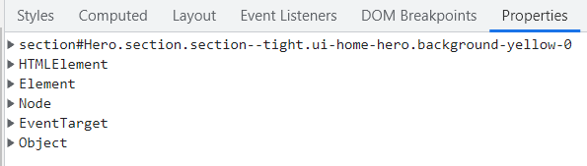

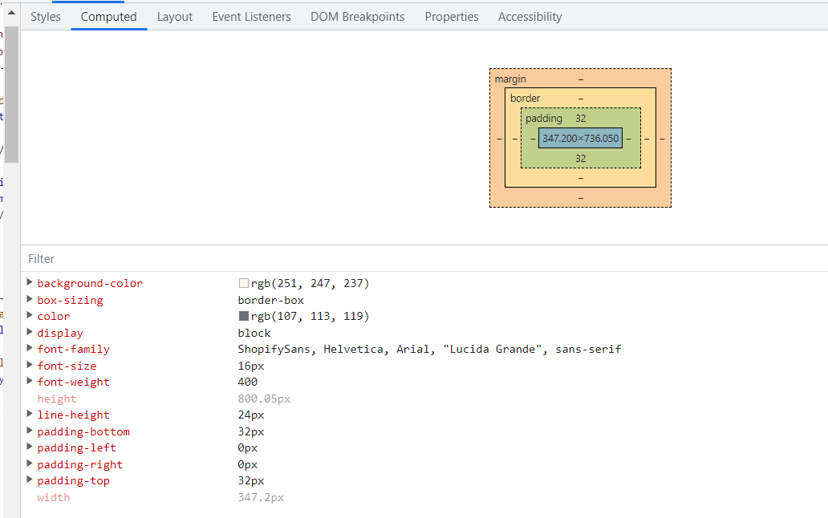

<https://wistia.com/>

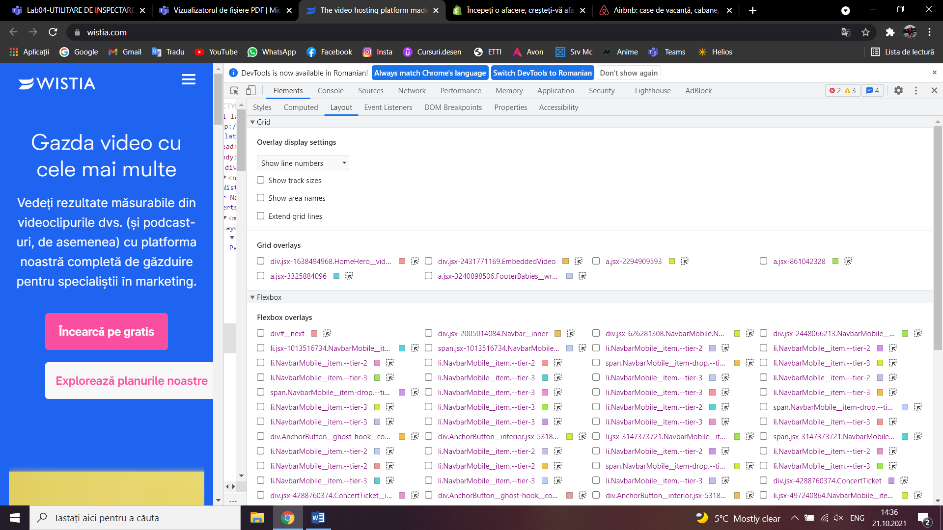

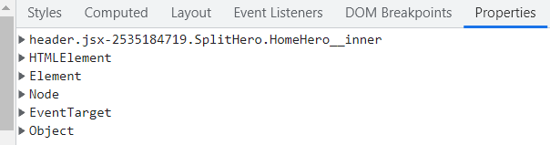

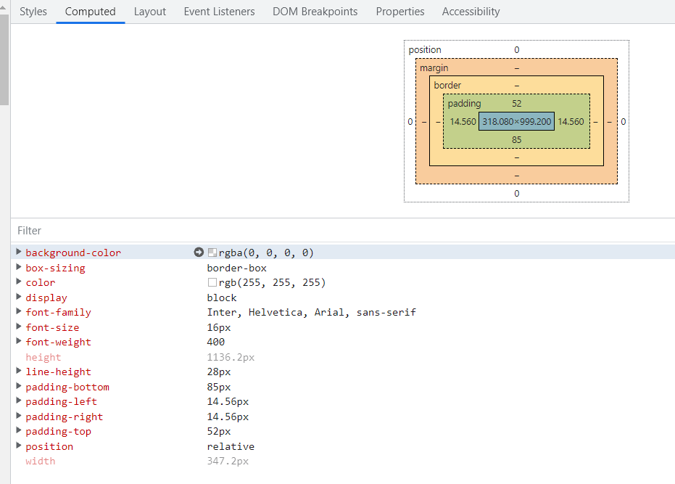

Comparam <https://developer.chrome.com/docs/devtools/> cu <https://www.google.ro/?gws_rd=ssl> (din microsoft edge)

|  |  |
| --- | --- |
| Asemanari | Deosebiri |
| Au 9 functionalitati identice (elements, console, sources, network, performance, memory, application, security si lighthouse) | Au 2 funcionalitati diferite: Google are Welcome iar Chrome are AdBlock |
|  |  |
|  |  |
|  |  |

2.

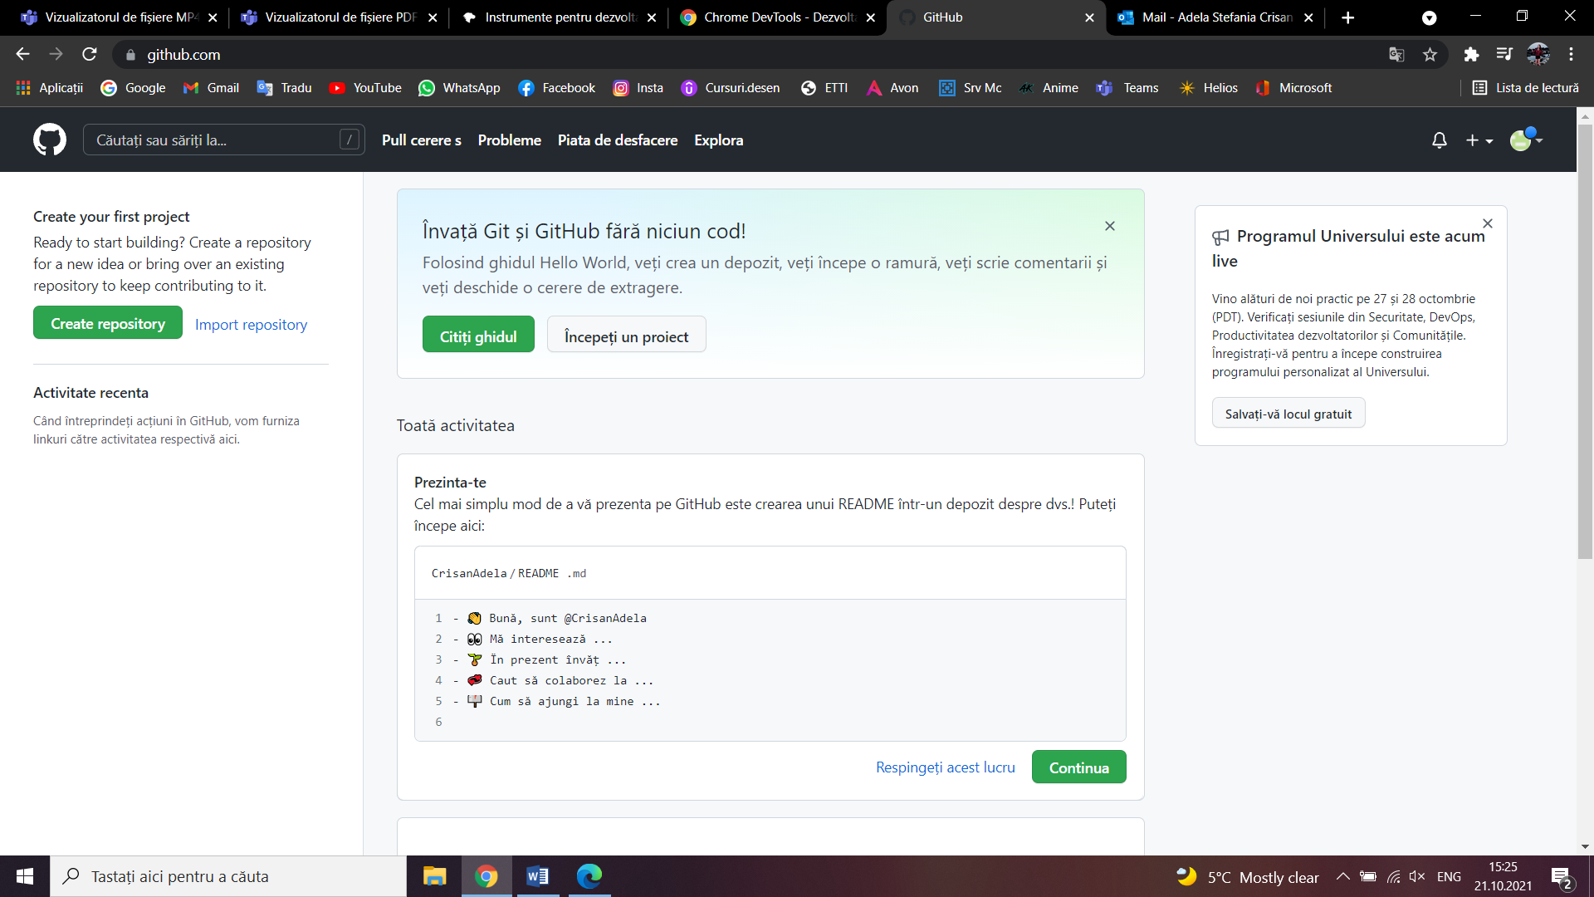

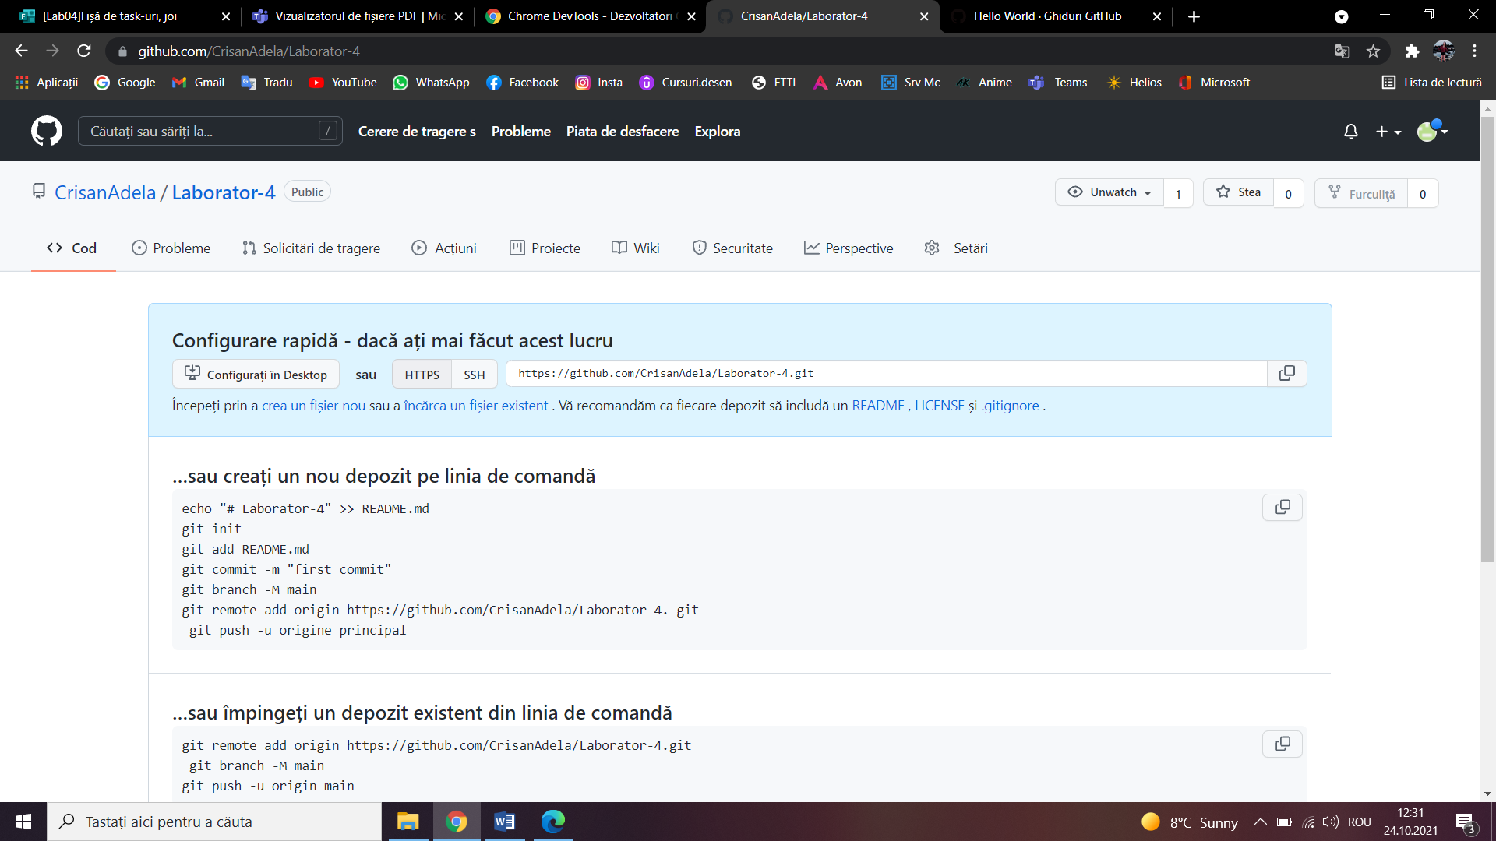

3.